**E-COMMERCE WEBSITE**

**PROJECT TITLE**

**SHOPPINGCART**

* **TEAM MEMBERS**
* MARYAM REHAN
* ANAS
* HAMZA
* MUHAMMAD UMAIR
* **PROFESSOR NAME**
* **AHMED ALI**
* **BATCH CODE**
* PR2-202310B1
* **SEMESTER**
* DISM

***CERTIFICATE OF COMPLETION***

This is to certify that MARYAM REHAN, ANAS MUHAMMAD UMAIR, HAMZA have successfully completed their ACCP 2 nd Semester (DISM) E-Project.

**SUBMITTED TO: APTECH COMPUTER EDUCATION**

**ON**

**SEPTEMBER-22-2024**

ACKNOWLEDGMENT

A quick responsive team with a friendly environment yet consistent pace of work is what the world demands from us IT professionals. However in a situation like now busy schedules and abstracted locations become a known barrier for causing a delay in the submissions of most of the project, forcing us to grasp better and more effective alternatives to prove our efficiencies.

We would like to acknowledge all those who have given moral support and helped me make the project a success.

Also we would like to express our teacher **SIR AHMED ALI** for his guidance and constant supervision as well as providing necessary information regarding the project.

I also express my sincere gratitude to the E-project Team at the Aptech Head Office.

ABRIDGEMENT

I and my crew worked for almost a week so the venture we started could come to an end. During this span of time my team and I faced some completely unpredictable complications which enhanced our knowledge about coding errors and its omissions. We failed on certain points however at last we advanced to the final progress.

PROBLEM STATEMENT

Marina Fleet website will present the information about the various fleets of yachts and boats available with them. The website will help the customers in choosing the yacht or boat as per their requirements. The company may also be benefitted with the information available on the website in reaching to wide range of customers.

Requirement Specification:

The Website is to be created based on the following requirements.

1. The Home Page should be created making use of Sections with a suitable logo, the header section can be added which will show images yachts and boats.
2. The site must contain the links to navigate through any category for the information.
3. Links of fleets can be categorized like (Luxury, Sailing, Fishing etc.).
4. Specification and Pricing of Yacht/Boat can be added along with the images.
5. Gallery section can be added for viewing different images.
6. Feedback must be allowed to enter by the viewer.
7. Site map, Gallery, about us, Queries link, Contact us link must be added.
8. The complete description must be allowed to get download as pdf or doc file.
9. The advertise section with various facilities provided should be mentioned.

**Hardware/ Software Requirements**

Operating System

* Windows 8
* Windows 10
* Or Higher.

System Requirements

* Visual Studio Code
* PHP
* JavaScript
* MY SQL
* HTML

# 

# **Architecture and Design of the System**

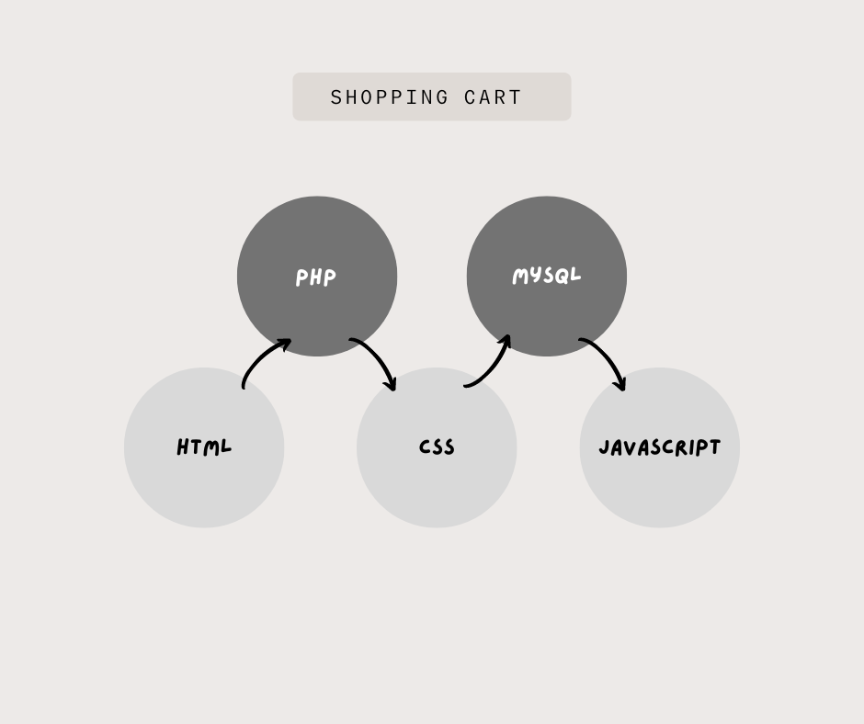



DEVELOPERS GUIDE

Using HTML, PHP, MYSQL on this project was a very convenient yet a simple way to express our creativity in different sorts of manner. This website is based on various classes and ids set in a consecutive manner with suitable names and a very readable coding structure so it could be smooth to understand it and make changes if necessary.

**SITE map**

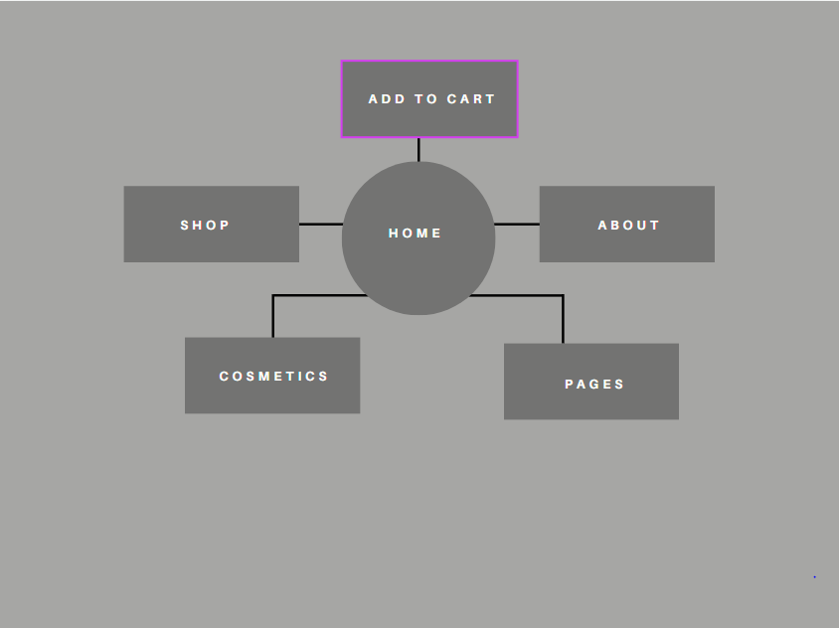

**USER GUIDE**

**WELCOME**

SIGN IN

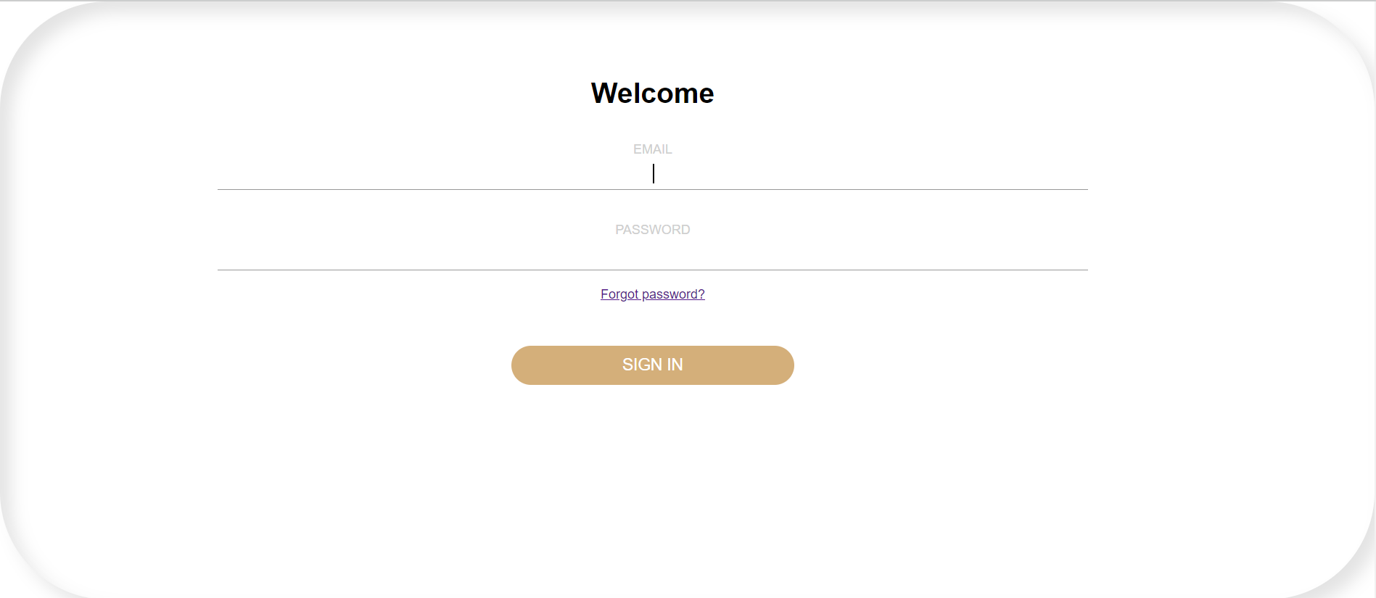

**SHOPNOW**

**NAVIGATION BAR**

The navigation bar is the host of the website which will help you explore the rest of the site. There are some of the options like Home, About us, Our Fleet, Shop, News, Contact us & Book Now button each of them which leads to another side of our project.

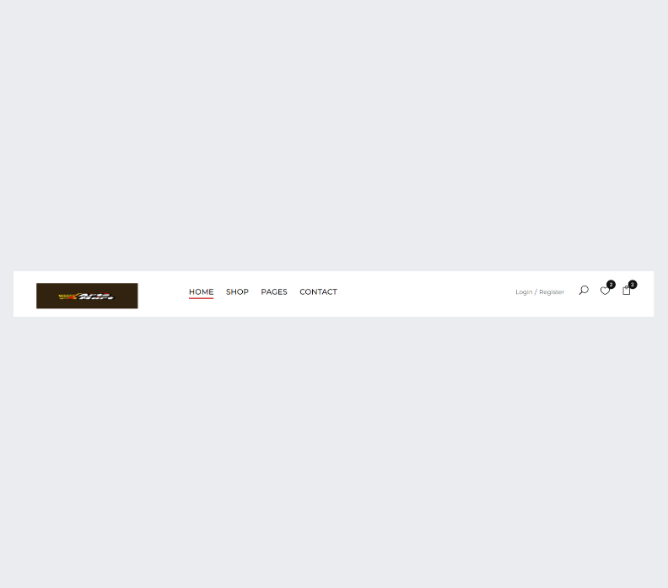

**HOME**

Home page is a main page of the website or could be termed as the introductory page containing some of our information and navigation bar at the top working as a gateway to other pages of the site.

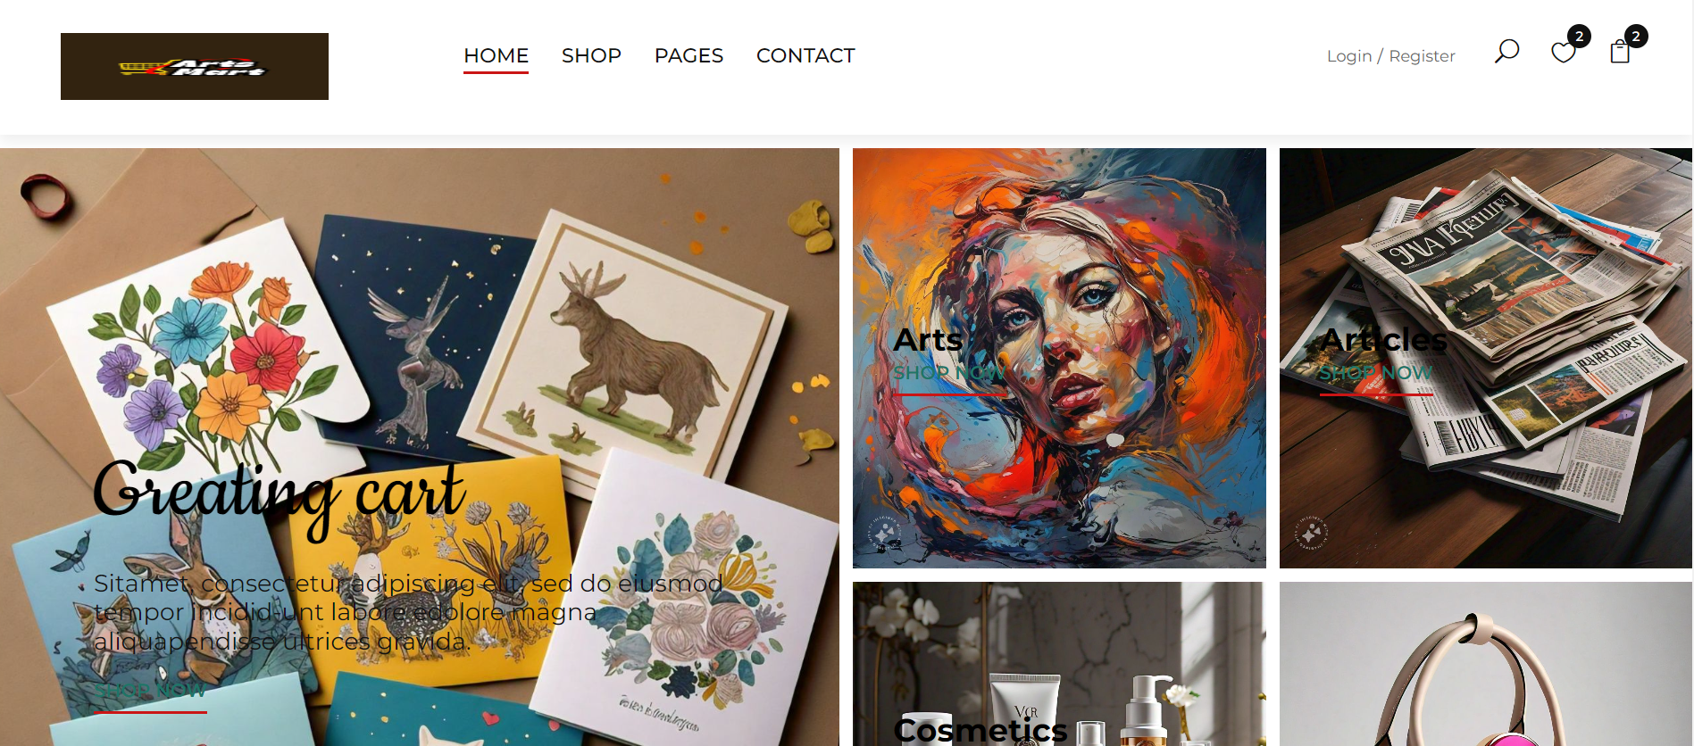

**PRODUCTS**

In about us, company show some introduction about them and includes our services, our missions and protection policy of the company.

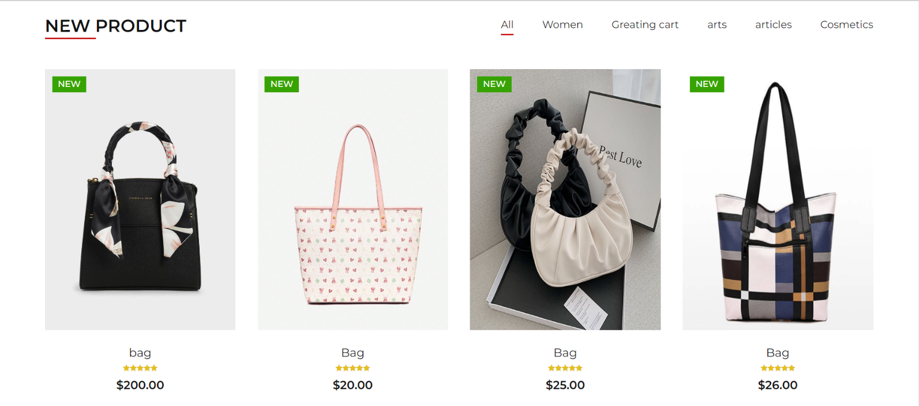

**COSMATICS**

Here we add drop-down button in our fleet button and after clicking drop-down it represents 3 categories of yachts such as Sailing Yachts, Motor Yachts and Fishing Yachts.

* BEAUTY PRODUCTS

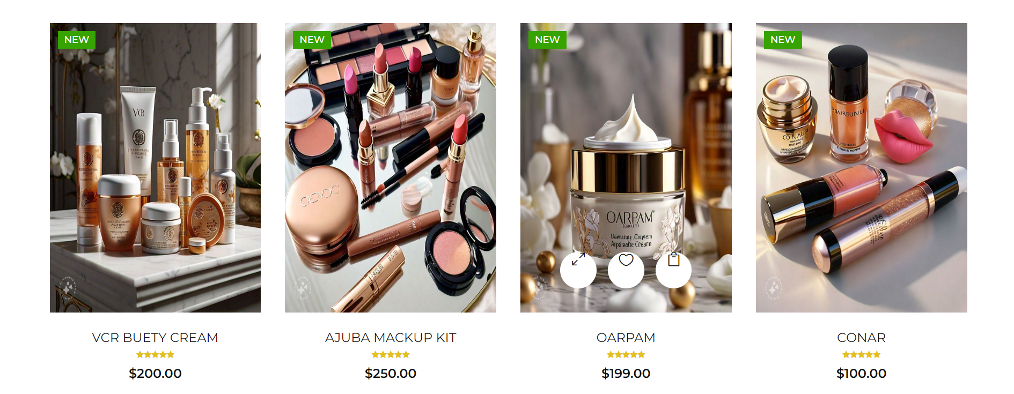

**ADD TO CART**

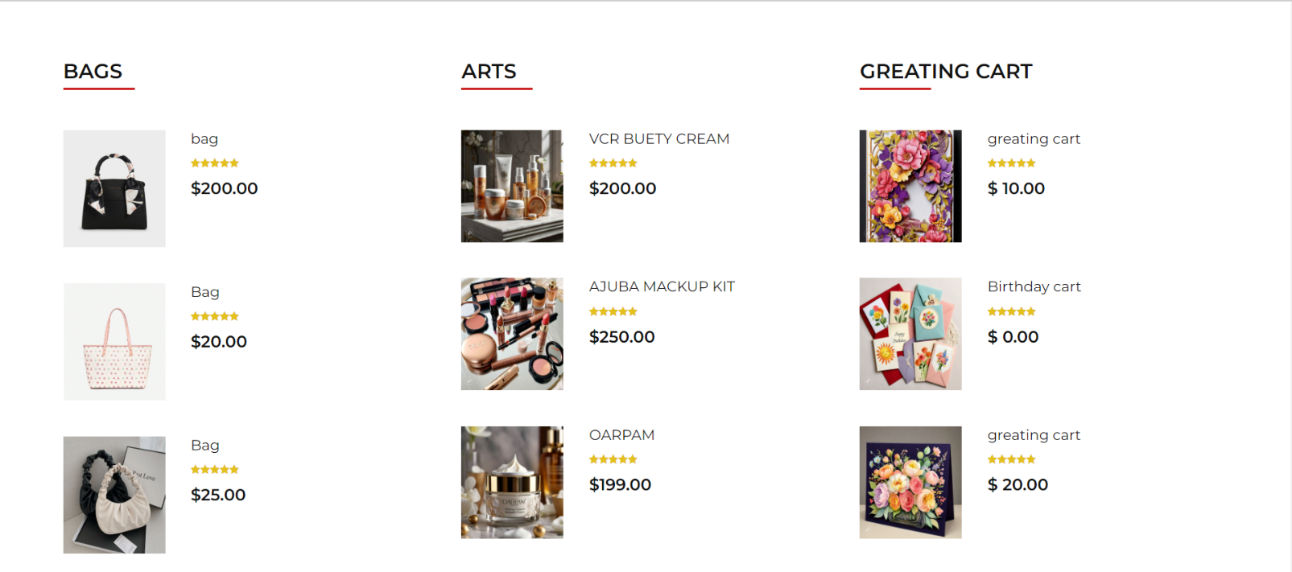

**DISSCOUNT OFFERS**

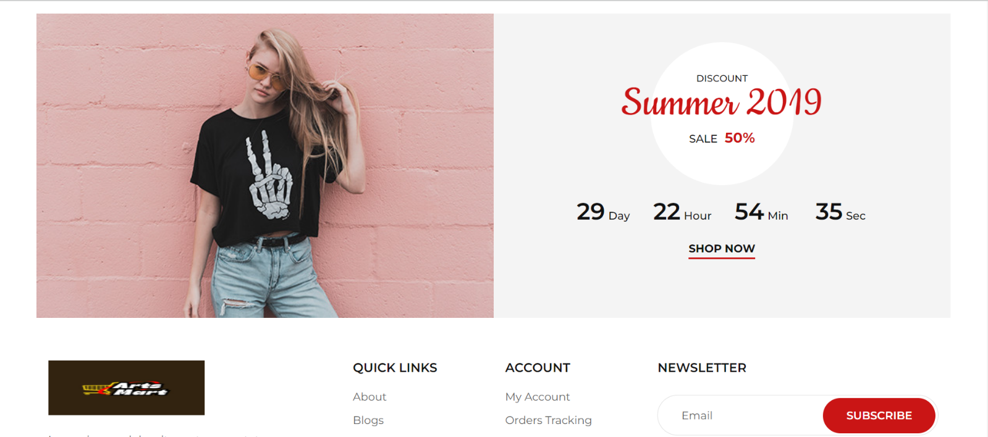



**CREATE ACCOUNT**

In this page, we add our email &amp; phone no. and customer can also send their message easily.

SIGN UP

